
Information Gathering (OCINT)
Muhammad Yar


Information Gathering
After running whois command on allstarhealth.com website I have checked following information

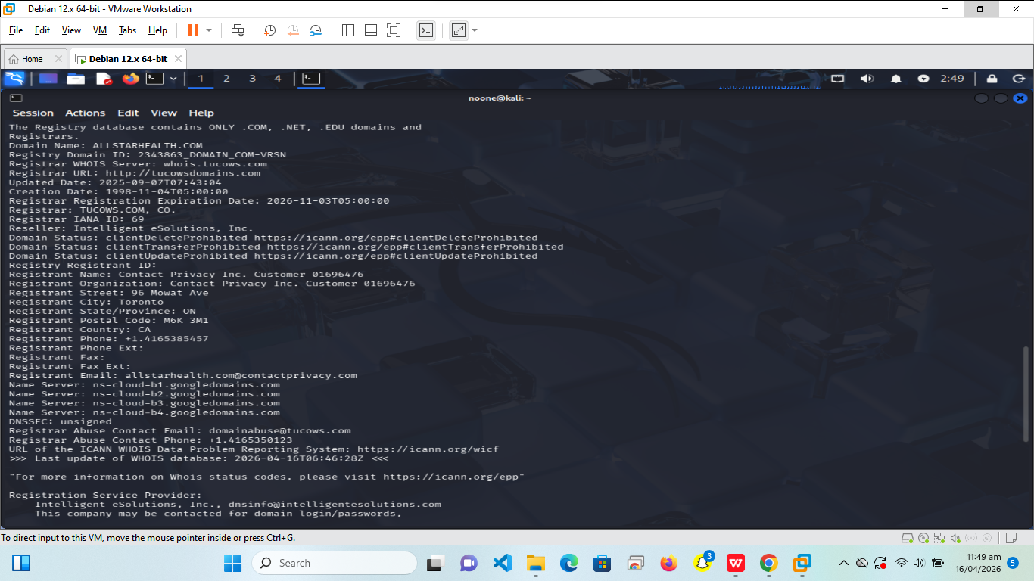
After running the allstarhealth.com, I have checked the following information
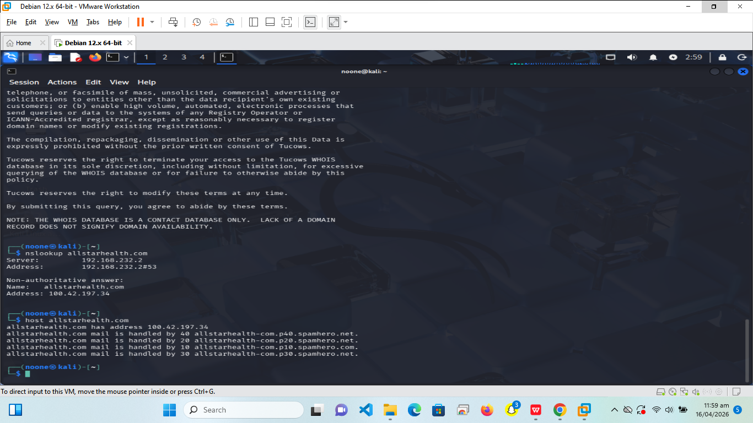

From Shudan.io I have check the information of open ports which is added below
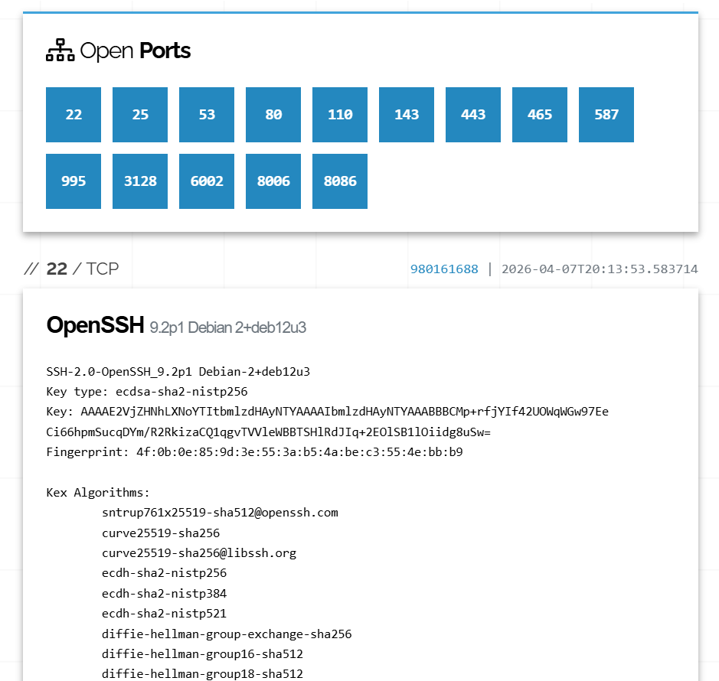
In Google dork I have performed site:allstarhealth.com query and received following details
